ADLM PNW Virtual Webinar on Nov 9th 4-5 pm PST
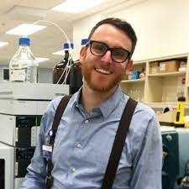
(Excel)lent Solutions: Leveraging Microsoft Excel In the Clinical Laboratory
Speaker: Alec Saitman, PhD, C(ASCP), DABCC (CC, TC)
Technical Director, Chemistry & Toxicology | West Division
LabCorp, Portland OR

Let’s all excel with Excel! Laboratorians are tasked with manipulating electronic data sets to manage analytical, clinical and logistical tasks daily. Microsoft excel is a powerful and widely available data analysis tool which is often underutilized by laboratorians. This interactive “online classroom” based session will walk the audience through multiple data analysis scenarios and allow them to work along with the speaker to practice each new skill in real time.
Please register for more details about the event: https://forms.office.com/r/pVctUdZ93H

At the end of the session the attendees will be able to:
- Apply excel formulas to perform simple data analyses.
- Plot data sets for visual analysis and create customized templates to save preferred formats.
- Use If/Then Statements along with conditional formatting to differentiate data values within data sets.
- Create simple macros to automate data analyses.

