UW Seattle South Campus, Room 303
May 4th, 2023, 5:00-6:30 pm
Hybrid Meeting: Virtual and In-Person Options
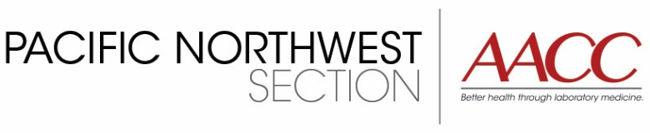

Developing and Deploying Data Analytic Applications for Clinical Laboratory Operations
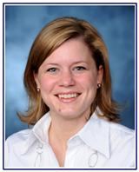
Speaker: Shannon Haymond, PhD, DABCC, FAACC
AACC President, Invited Lecture
Vice Chair for Computational Pathology and Director of the Clinical Mass Spectrometry Laboratory at the Ann & Robert H. Lurie Children’s Hospital of Chicago
Associate Professor of Pathology at Northwestern University Feinberg School

Join us on May 4th to listen to an exciting talk from AACC President, Dr. Shannon Haymond, on the University of Washington Campus in Seattle! A social hour and dinner will take place at Magnuson Brewery after the talk.
RSVP for more details! https://forms.office.com/r/vjkuHjunxq

